Assignment Submission All at Once Clone Detector

Processing the Entire Qualitas Corpus:
I successfully processed the entire Qualitas Corpus, although the expansion of clones took a large amount of time. I believe we can improve the cljDetector code by exploring opportunities for parallel processing, especially within the map steps of the cljDetector. This optimization could improve overall efficiency.

Report

Time to generate Chunks
The process of chunkifying and storing data chunks in the database took approximately 69 minutes. I routinely scan the database collection of chunks at 60-second intervals. The below graph illustrates the fluctuating number of chunks added to the database each minute. As evident from the graph, the quantity of chunks being added reveals large variability from minute to minute. Based on my analysis, the database holds anywhere between 7500 to 472700 of additional chunks when examined at 60-second intervals.
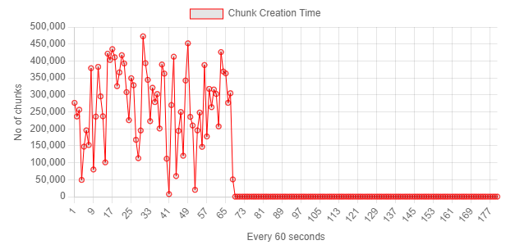
Figure 1 First run
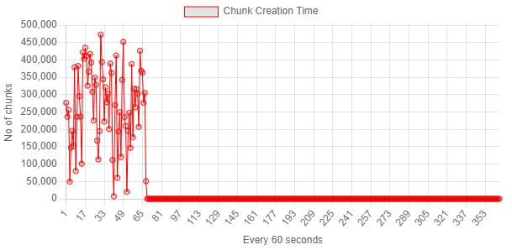
Figure 2 second run
These large variations can be due to several factors, including differences in file sizes and the partitioning size utilized in the process. My statistical analysis shows no obvious increase in the time required for creating chunks as the number of processed chunks are increasing. Adjusting the partition size based on the average chunks per file could be considered for further optimization.

Time to Generate Clone Candidates:

The generation of clone candidates took around 45 minutes according to my statistical analysis. However, with the existing implementation of the Clojure code, there is no mechanism to monitor the progress or track the time required for each clone candidate's generation. The identification of clone candidates in the Clojure code relies on the MongoDB aggregation pipeline. At the conclusion of this process, all candidates are collectively inserted into the database collection named "candidates" in bulk, giving rise to the observed graph in the monitoring tool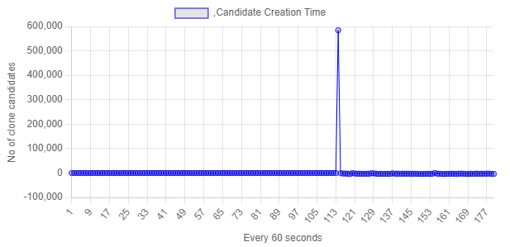
Figure 3 Frist run
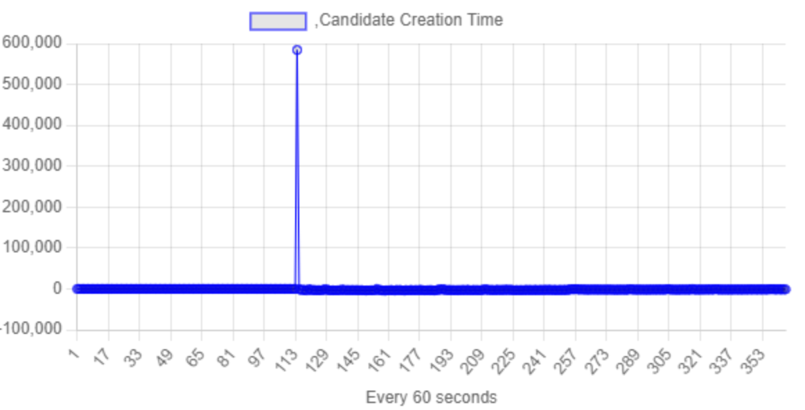
Figure 4 Second run

Time to Expand Clone Candidates:
The duration for expanding clone candidates fluctuates based on the quantity of already expanded clones or the remaining candidates, as illustrated in the graph below. Notably, the operation accelerates as the number of remaining candidates decreases. The graph shows an almost exponential increase in the number of expanded clones towards the conclusion of this process. Despite this, it's clear that this specific section of the Clojure code responsible for this task consumes a significant amount of time, adding about 250 minutes.
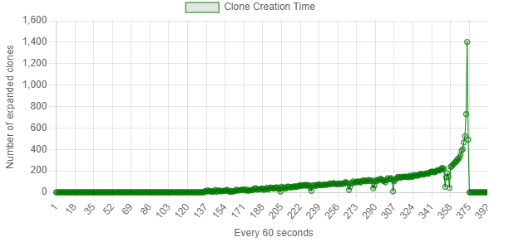
Figure 5 First run
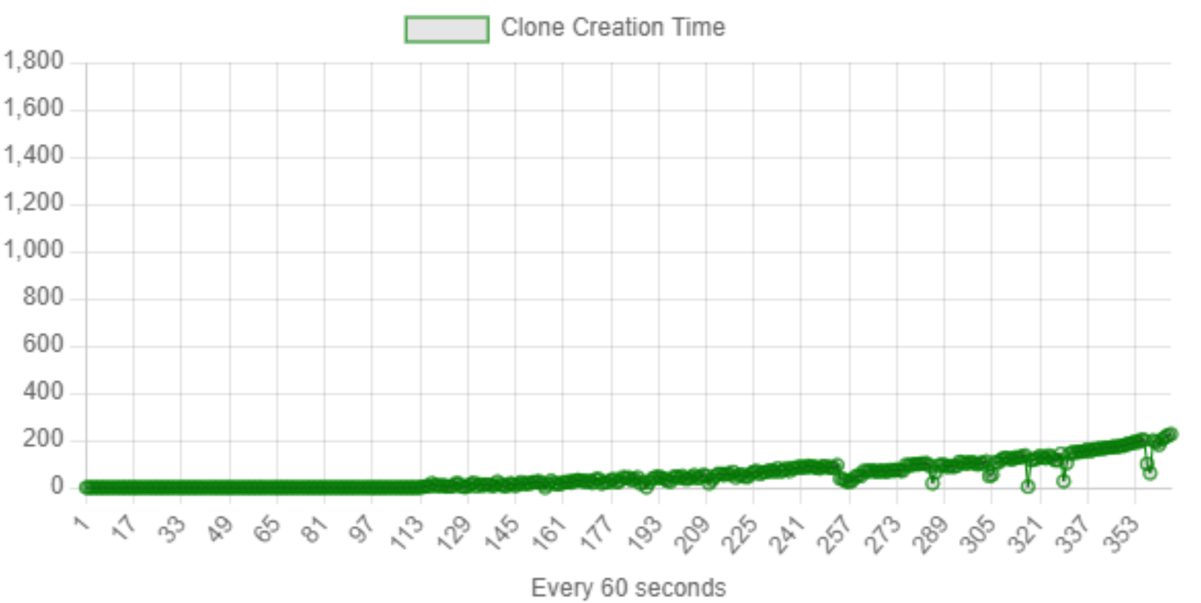
Figure 6 Second run

Average Clone Size
The average clone size is calculated as 44 lines from my stats. Average clone size might help us to track how our expansion phase is going. As we expand, we see the number of clone candidates going down, giving us an idea of progress. Combining this with the average clone size gives us an idea of how close we are to the end of the process.

Average number of chunks per file

With an average of 160 chunks per file, this number becomes helpful to predict progress during the chunkify and identify candidates' stages. Since reading files is a quick process, we find out the total number of files very quickly. Knowing the average chunks per file and the total file count helps us estimate the total number of chunks we can expect. While checking the database for chunks, we can figure out how much work is still left.

Raw data
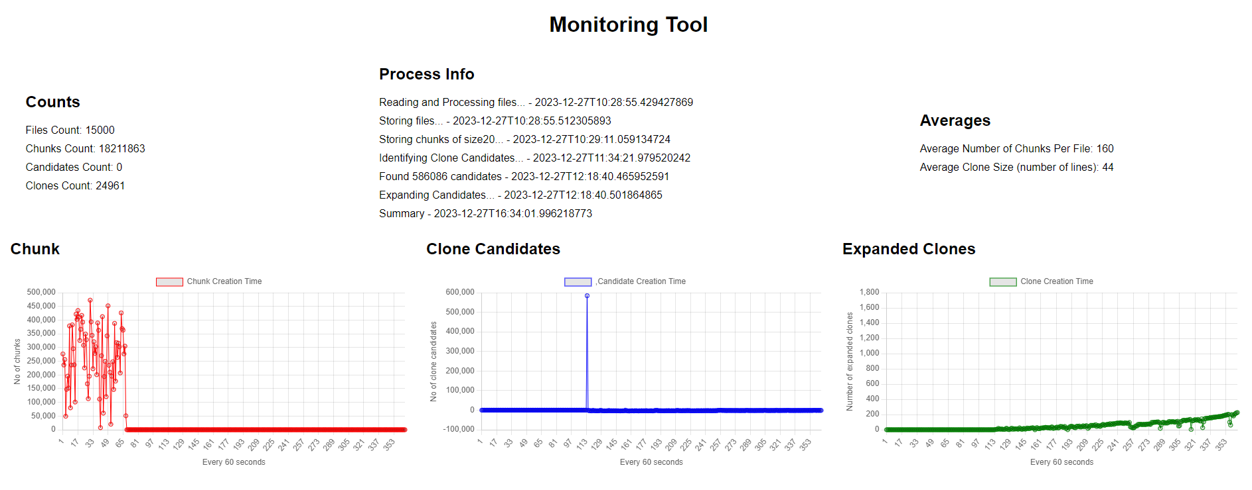

Code submission:
The zip file containing the modified cljDetector and MonitorTool code, along with the Docker Compose YAML file, has been uploaded. Modifications in cljDetector are highlighted for easy review.

